SUMMER TERM MAT 1033 (2360)
EXAM 1 (Window 07/20/2020 through 07/22/2020 at 11:59 pm)
- Calculate the slope of the line that goes through the two points M & N and the slope of the line graphed below. Show your work for full credit.

Slope of the line in the graph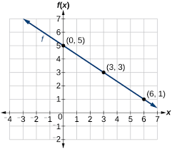
Points (6, 1) and (0, 5)
$\frac{5-1}{0-6}$ = $\frac{4}{-6}$
-$\frac{2}{3}$ = slope

- M(-4, -7) and N(-7, -13)
$\frac{-13+7}{-7+4}$ = $\frac{-6}{-3}$ 2 = is the slope
M=2 B=1

b) y-5=-2/3(x+0)
Y= $\frac{-2}{3}x+5$
M = $\frac{-2}{3}$ is the slope

- Graph the linear equations and state the slope.
- Y = (-3/5)x + 1
The slope is $\frac{-3}{5}$
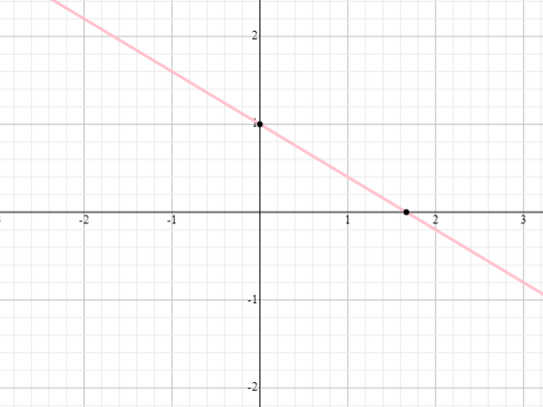

B) Y = -1
The slope = 0

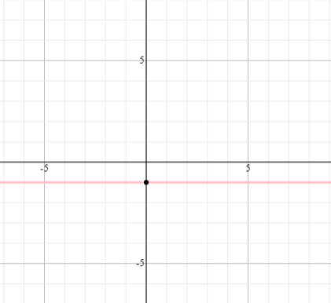

c) X = 2
The slope is 0
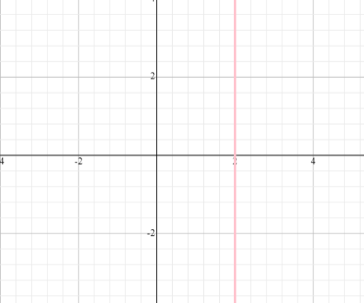

d) Y = -3x

The slope is -3
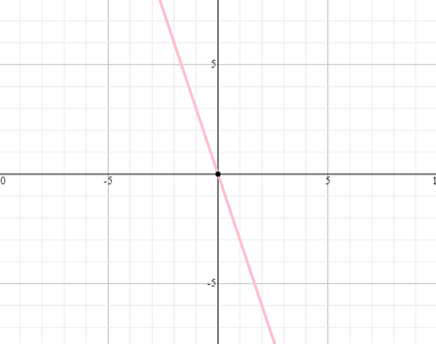

- Solve the following equations:
- -3(x – 2) = 5 - 2x X=1
-3x +6 = 5-2x
6-5 = -2x+3x
1= x

- - t – 4 = - 4 – 3t t=0
-t-4 = -4 -3t
-t+3t= -4 +4
2t = 0
t=0

- Solve the following inequalities:
- 4 – 4x > - 16 + x x<4
4 -4x > -16 +x
4 +16 > 4x+x
20>5x
4>x

- 5 + x < 3 x<-2

5+x<3
X< -5 +3
X<-2

- Graph each of these inequalities
- Y > (-2/3)x – 1

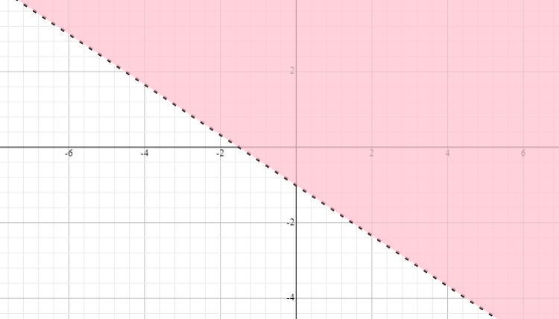

- x <= 2
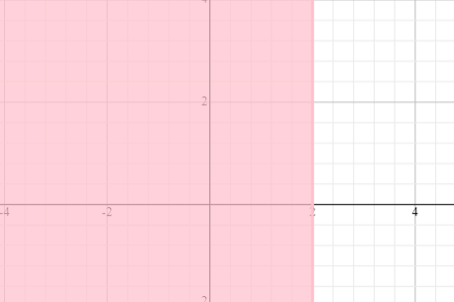

- Solve the following systems of equations and state whether each of them is consistent, inconsistent and/or dependent, independent:
- 3x + y = 1 X=0.3,x=3־¹
3x + 2y = 6

Take the difference of the equation
3x+y =1
-
3x+2y=6
= -y= -5
Y=5
3x+5=1
3x=-4
X=-4/3 the equation is consistent and it is independent

- x + y = 4

x + y = 3
Take the difference
0 =1
No solution therefore the equation is inconsistent and it is dependent

- Henry is going up the hill to meet his friend. According to what we have learned in this course, which type of slope is he driving on? Positive Slope
It is positive slope because there is steeper upward tilt to the line.

- What specific information can help you determine whether an equation is linear or not? A linear function creates a straight line when graphed on a coordinate plane. It is made up of terms separated by a plus or minus sign. To determine if an equation is a linear function without graphing, you will need to check to see if your function has the characteristics of a linear function. Check that the y, or independent variable, is by itself on one side of the equation. If it is not, rearrange the equation so that it is.

- Circle the graph of the lines with a positive slope and the undefined slope.
POSITIVE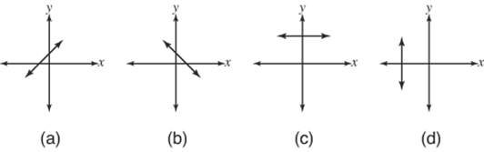UNDEFINED
- Create your own linear inequality and graph it on a coordinate plane.
- Y< 4x+4

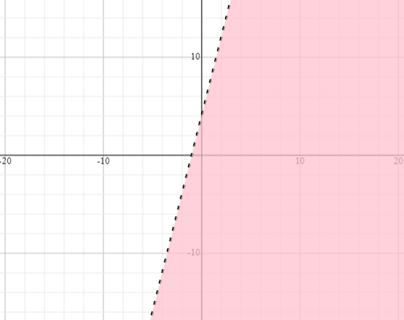

- y≥ -1/3x -5

